A Project Report

# On

**“*Face Verification Management System”***

Submitted to

Vidyasagar University

**for the partial**

**Fulfillment of the Requirement for the Award of the Degree of Bachelor of Computer Application (BCA)**



**Submitted By**

**Gouranga Nayek**

*Roll: 46120106 No.012*

Reg. No: *0000065* of Year: 2020-2021

**Apurba Sau**

*Roll: 46120106 No.005*

Reg. No: *0000058* of Year: 2020-2021

**Arnab Maiti**

*Roll: 46120106 No.006*

Reg. No: *0000059* of Year: 2020-2021

**DEPARTMENT OFCOMPUTER APPICATION**

**Debra Thana Sahid Kshudiram Smriti Mahavidyalaya**

Gangaramchak, P.O.: Chakshyampur, District: Paschim Medinipur, PIN: 721124.

### CERTIFICATE

*This is to certify that* ***Apurba Sau****(Registration Number 0000058 of 2022-2023 and Roll*

*46120106 Number 005),* ***Arnab Maiti****(Registration Number 0000059 of 2022-2023 and Roll*

*46120106 Number 006),* ***Gouranga Nayek****(Registration Number 0000065 of 2022-2023 and Roll 46120106 Number 012), of Department of BCA,* ***Debra Thana Sahid Kshudiram Smriti Mahavidyalaya****, Debra, West Benagl-721124, has successfully completed their final year project entitled “****Face Verification Management System****” for the award of the degree Bachelor of Computer Application (****BCA****) from Vidyasagar University, is a record of bona fide project work carried out by them under my guidance and supervision.*

##### Prasanta Dutta

State Aided College Teacher Department of BCA

Debra Thana SahidKshudiramSmritiMahavidyalaya

### ACKNOWLEDGEMENT

We acknowledge with gratitude the interest that Mr. Prasanta Dutta took in providing us withvaluable information and guidance regarding the field training.

We are highly indebted to the BCA Department for their guidance and constant supervision, as well as for providing necessary information regarding the project and for their support in completing theproject.

At last, we would also like to extend our thanks and gratitude to all the people who were directly orindirectly involved in helping us during training.

Project Members

**Page 3**

|  |  |  |  |  |
| --- | --- | --- | --- | --- |
| CONTENT | | | | |
|  | sl.No. |  | Page no. |  |
| 1 | List of abbreviations | 5 |
| 2 | Introduction | 6 |
| 3 | Project Plan | 7 |
| 4 | About Project | 8 |
| 5 | Introduction to facial recognition | 9 |
| 6 | History of Facial Recognition | 10 |
| 7 | Importance of Facial Recognition System | 11 |
| 8 | Challenges of Facial Recognition System | 12 |
| 9 | Requirement Analysis and Feasibility Study | 13 |
| 10 | Non-Functional Requirements | 17 |
| 11 | Method and Materials | 19 |
| 12 | Methodology | 21 |
| 13 | Flowchart | 22 |
| 14 | Use case diagram | 24 |
| 15 | Data flow diagram | 25 |
| 16 | ER diagram | 28 |
| 17 | Code implementation | 29 |
| 18 | Snap shot | 32 |
| 19 | Result & Discussion | 41 |
| 20 | Conclusion | 42 |
| 21 | References | 43 |
|  | **Page 4** | | |  |
|  | | | | |

# List of Abbreviations

LBPH: Local Binary Pattern Histogram SDLC: Software Development Life Cycle SQL: Structured Query Language

CSS: Cascading Style Sheets HTML: Hypertext Markup Language UI: User Interface

FERET: Face Recognition Technology

DARPA: Defence Advanced Research Projects Agency NIST:National Institute of Standards and Technology FRVTs: Face Recognition Vendor Tests

ORM:Object -relational Mapping

## Introduction

The success of an educational institute begins by engaging employees and having regular attendanceof employees. Having a higher attendance score results in higher marks, higher retention rates, and abetter educational experience. It is difficult for teachers and employees to build a strong relationship if employees are frequently absent. This hampers teachers and employees to develop their skills and make progression. In many schools, the school budgets are based on the average daily attendance of the school. If the attendance rates are low, then school budgets suffer. Hence, schools have less money to get essential classroom needs for employees and eventually end up with less quality

education. Therefore, the educational institute needs to have high-quality attendance data. These data provide essential information for the institute to formulate policies, programs, and practices toimprove attendance rates. To increase the attendance of employees, many teachers give better grades to the employees with higher attendance scores.

Even though keeping attendance data is an essential part of educational institutes, there has been little advancement in the attendance system. Still, many institutes use traditional handwritten attendance or use some spreadsheet on the computer. This makes it hard for teachers to track theemployees’ attendance data and their progress. Chances of attendance fraud in this system are

relatively higher than it is in automated attendance system. Unless the attendance data is correct, schools cannot formulate proper policies and practices to improve the quality of education.

This project will help eliminate the traditional attendance system, minimize manipulation during attendance and record the arrival time of the employees. It is also very easy to use and manage. Likeevery application, there are some setbacks to this application. The application is not one hundred percent accurate. Different factors such as image quality and lack of data sets can decrease the

efficiency of the application. Administrators must add user

information manually and with data sets stored associate with the risk of being lost or stolen. The fundamental introduction of our project is given in section 1. It includes a background study of the project, the objectives set to meet, scope and limitations of our final product. The history of facial recognition and its introduction is provided in Section 2. The advantages and drawbacks of the facialrecognition system are discussed in this section.

|  |  |  |  |
| --- | --- | --- | --- |
| **PROJECT PLAN**  Project planning defines the project activities and end products that will be performed and describes how the activities will be accomplished. The purpose of the project planning is to define each major task, estimate the time and resources required, and provide a framework for management review and control. The project planning activities and goals include defining:   * The specific work to be performed and goals that define and blind theproject. * Estimates to be documented for planning, tracking, and controlling theproject. * Commitments that are planned, documented, and agreed to by affectedgroups. * Project alternatives, assumptions andconstraints.   **Project Plan Table:-** | | | |
|  | **Month** | **Activity** |  |
| February | Feasibility Study and Analysis and  Requirement Gathering |
| March and April | Implementation |
| May and  June | Testing and Documentation |
|  | **Page 7** | |  |
|  | | | |

### About Project

* In many public and educational sectors, the management system is mandatory for analyzing the performance of candidates. When there are a lot of individuals in an organization or institute, it becomes significantly more difficult to mark their presence through the manual procedure and it is also time-consuming. The conventional marking method is obsolete, and in such systems, identification is recorded with traditional approaches that include registers and sheets whereas more advanced methods like RFID and biometric encounter the difficulty of time wastage and are significantly more complicated where you have to wait in line to swipe the RFID card or put your thumb on a scanner which can be a quick way of spreading unwanted diseases. It is also prone to manipulation where individuals can mark the presence of others without any oversight if they possess the RFID card. Sorting and calculating the attendance of every enrolled person is not only tiresome but humans can easily make mistakes while conducting repetitive tasks. Therefore, a smart system is required for marking and recording. In order to do that, we will save an authentic and proper record of persons that can also be analyzed later on if needed.
* In addition to reducing errors, the proposed system for management is also more feasible than other methods. For example, the biometric system needs more hardware, and its maintenance is also difficult. The automatic system can resolve a crucial issue within the manual one that occurs when a person transfers the information from the sheet into the system. The face identification method has many steps which include capture, extraction, comparison, and matchmaking. An automated and computerized attendance information and management system with enhanced face identification has been proposed. The initial steps include database creation, face identification, feature engineering, and categorization stages followed by the last stage, i.e., postprocessing phase [1]. At first, facial images of every student would be transferred to the system and saved within the database. Then, the identification of candidates is recorded by using a camera attached within the area at an appropriate location from where the entire region is often viewed or monitored. The camera will constantly take pictures of candidates, identify the countenances in pictures, recognize the identified countenances, and mark their identity. In some methods, the camera is at a fixed position at the point of entry to capture the image of the candidate as they enter that area. Through this technique, we will save more time as compared to the manual management system. Finally, if sorting is needed, then it can also be done easily.

### Introduction to Facial Recognition

A person’s face has distinctive physical shape and characteristics that are used to identify or verify anindividual. Facial recognition records this biometrics of the face. Different face recognition methods measure the biometric of the face.

Facial recognition has become a very important topic in recent years. Facial recognition is effectivelyapplied in various applications like security systems, authentication, entrance control, surveillance system, unlocking of smartphones and social networking systems, etc. Most of the practices do not use facial recognition as the main form of conceding entry. However, with advancement in

technology and algorithm, facial recognition system has the potential to replace the standardpasswords and fingerprint scanners.

This project was carried out to show how a Local Binary Pattern Histogram (LBPH) face recognizercould be used for taking attendance of employees. LBPH facial recognizer is a pre-trained facial recognition classifier. If enough data set are available on the face that is needed to be identified, LBPH can perform facial recognition with high accuracy. Face Recognition Employee Attendance

System is a desktop application that identifies and verifies employee’s identities with the help of a

digital image. Once the recognized face matches with the stored image, the attendance is completed and marked in the database for the employee. This system will provide an alternative and easier wayof taking attendance.

The facial recognition system has three main phases, which are described below:

##### Face Detection

Face detection is the ability to identify the person’s faces within the digital images. This system

identifies the human face present in an image or video. We need to define a general structure of aface to determine certain picture video contains a face (or several). Human faces have the same

features such as eyes, nose, forehead, mouth, and chin. Therefore, the objective of face detection is to find the location and size of the face in an image. The located face is then used by the facial

recognition algorithm.

##### Feature Extraction

In this phase, we are extracting the features from the detected face. In LBPH, the first local binarypattern images are computed, and a histogram is created for facial recognition. This generates a template. A template is a set of data that represents the unique and distinctive features of the detected face.

##### Face Recognition

Face Recognition is being able to uniquely identify and verify a person’s face by comparing and analyzing a biometrics person’s face. A face recognition system is an application that is used foridentifying or verifying a person from a digital image.

### History of Facial Recognition

Woody Bledsoe, Helen Chan Wolf, and Charles Bisson were the earliest pioneers of facial recognition. They began working to recognize the human face using a computer in 1964 and 1965. They marked various landmarks on the face such as eye centers, nose, mouth manually. They later used the computer to mathematically rotate to compensate for pose variation. The distances between the facial landmarks were computed automatically and compared with the image to match the identity. This was the dawn of facial recognition.

Sirovich and Kirby applied linear algebra to facial recognition and made it a viable biometric forbusiness. They developed a system called “Eigenface”

where less than one hundred values were required to code the facial image accurately. In 1991, thediscovery of face detection within an image by Turk and Pentland led to the beginning of automatedfacial recognition. This paved the way for the advancement and development of facial recognition technology.

FERET program was rolled out in the early 1990s by the DARPA and NIST for commercial facial recognition. They created a database for facial images, which included 2413 facial images that

represented 856 people. In the early 2000s, to provide independent government evaluations of facialrecognition system and its prototype technologies, FRVTs was designed. These evaluations provided

the necessary information to deploy the facial recognition technology in the best way to the law

enforcement agencies and government. Face Recognition Grand Challenge was launched in 2006 to evaluate the face recognition algorithms available. It used high-resolution images, 3D face scans, andiris images for the test. The test concluded that the new algorithm was 10 times more accurate than the algorithms of 2002 and more than 100 times more accurate than the algorithm of 1995. In recentyears, Facebook has implemented facial recognition functionality to identify people featured in the user’s daily updates.

In 2017, Apple launched the iPhone-X, which was the first iPhone to implement facial recognition to unlock the phone.

### Importance of Facial Recognition System

Applications using facial recognition systems are widespread. They are applied in security systems, authentication systems, verification systems, surveillance systems, etc. We are interacting with facerecognition systems without even realizing it. Many Businesses are using facial recognition systems for authentication, verification, and security. There are diverse applications of this system. Countriessuch as United States, United Kingdom, and Australia are now installing facial recognition

technologies in different public spaces such as airports, cafes, shopping areas, factory areas, and government buildings. A large retail company like Alibaba is working on the development of pay-by- face technology. Workspaces are using this technology to record the clock in and

clock out tine of the employees. Law enforcement agencies are installing cameras with facialrecognition systems to identify criminals and search for missing persons. As facial recognition

technology and algorithms advance, we would see it being implemented more and more in oursociety.

### Challenges of Facial Recognition System

A facial recognition system can revolutionize how businesses and governments interact with people. However, if not used properly, there are potential pitfalls with this technology. Potential misuse of personal and sensitive information is very real. Businesses and Organizations need to make sure thatthere are proper checks and balances and proper security before implementing this technology. Every time this technology scans someone’s face, the distinct biometrics of the person is stored in adatabase. Depending on who owns the database and security in place to protect the database, the information can be leaked, stolen, or misused without the consent of the person. Facial recognition

systems are not perfect. Data collected by humans are used to train the algorithms. If there are a lackof data and a diverse array of data to train the algorithms, the system can misidentify the person.

There have been many instances where the system incorrectly identified the gender or identity of people with darker skin tones. This happened because of a lack of data representing a diverse arrayof people.

With the advancement of new technology comes a new type of crime. Criminals could access thefacial recognition data by hacking the database and track people’s movement, location, and

information without their consent. Criminals can cause significant damage with the aid of a facialrecognition system. They can steal sensitive personal information or the identity of a person to commit a crime.

The application of facial recognition technology holds many promise. However, it needs to be

handled carefully. Businesses that want to implement this technology need to implement the properframework and facial data protection

measures. If successfully managed to implement this technology, they can reap the benefits of thistechnology.

### Requirement Analysis and Feasibility Study

This section of the thesis describes the requirements necessary for the project and its feasibility.

* + **Literature Review**

Viola-Jones algorithm is used to detect the face. A camera is set up in the classroom that scans the facial structure of the employees. The detected face is extracted for further processing. 20 images of employees are stored in the database as the dataset. These datasets are used to compare the

biometrics with the detected face for facial recognition. Facial recognition is done using LBPH. LBPH extracts the histogram of the image and concatenates it to form the face descriptor by segmentingthe image into the local region. The distance between the biometrics of the probe image and the

trained image is calculated. If the calculated distance is less than the threshold, then the probe imageis recognized. Once recognized, the name is updated into an excel sheet.

* + **Requirement Analysis**

**Tool and technique**

In this project we are use various type of tool and technique. Such as :-

* + **Tools**

**Cv2 :** cv2 refers to the OpenCV library, an open-source computer vision and image processing library commonly used in Python. It provides a wide range of functions and tools for tasks such as image manipulation, object detection, and feature extraction. Its versatility and extensive documentation make it a popular choice among developers working on computer vision applications.



**Tkinter :** Tkinter is a standard Python library used for creating graphical user interfaces (GUIs). It provides a set of tools and widgets to build windows, buttons, menus, and other interactiveelements. With its simplicity and cross-platform support, tkinter is a convenient choice for

developing desktop applications with a graphical interface in Python.



**Face recognition:** Face recognition is a technology that identifies and verifies individuals based on their facial features from images or videos. It involves detecting faces, extracting facial

features, and comparing them with a database to recognize a specific person. This technology finds applications in various fields, including security systems, user authentication, and personalized userexperiences.

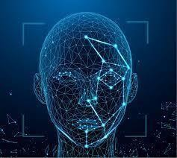

**Mysql :** MySQL is a popular open-source relational database management system, and inPython, it can be accessed using the mysql-connector-python library. This library enables Python developers to interact with MySQL databases, allowing them to perform tasks like querying,

inserting, updating, and deleting data. It provides a convenient way to integrate MySQL databasesinto Python applications for data storage and retrieval.



* + **Technique :**

**Haar Cascade Classifier** : The Haar Cascade Classifier is a machine learning-based object detection method used to identify objects in images or videos. It utilizes Haar-like features to capturepatterns and variations in intensity, enabling it to detect specific objects such as faces,

eyes, and

smiles. Haar Cascade classifiers are fast and efficient, making them suitable for real-time applicationsin various computer vision tasks.

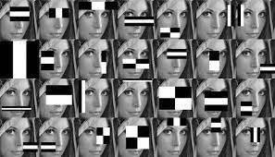

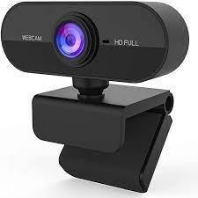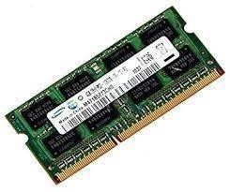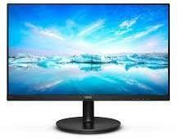

### Hardware Requirements

**Webcam :** In this project, the webcam is the main and vital tool. It takes the image for recognition. Itneeds a minimum of 0.3 MP and more image resolution.

**RAM :** This program requires at least 4GB of RAM to run. It gives a more efficient result at more than4 GB of RAM.

**Display :** A display is needed to show the output. There are many items to view. It has a frontend, so it must have a display to use the graphical user interface.

**Page 17**

### Non-Functional Requirements

Non-Functional Requirements are the characteristics or attributes of the system that are necessaryfor the smooth operation of the system. Those requirements are listed below.

* The system should perform the process accurately and precisely to avoid problems.
* The system should be easy to modify for any updates. Any errors or bugs that are identifiedshould be easy to mend.
* The system should be secure and maintain the privacy of the employees.
* The system should be easy to understand and use.
* Execution of the operation should be fast.
  + **Feasibility Analysis**

A feasibility study evaluates the project's potential for success; therefore, perceived objectivity is animportant factor in the credibility of the study for potential investors and lending institutions. . It must therefore, be conducted with an objective, unbiased approach to provide information upon

which decisions can be based. Here, we discuss 3 major feasibility studies required for our project.

* + **Operational Feasibility**

Operational feasibility is the measure of how well a proposed system solves the problems with the users. Operational feasibility is dependent on human resources available for the project and involvesprojecting whether the system will be used if it is developed and implemented. The project is

operationally feasible for the users as nowadays almost all the teachers/staffs are familiar with digital technology.

* + **Economic Feasibility**

Economic feasibility defines whether the expected benefit equals or exceeds the expected costs. It isalso commonly referred to as cost/benefit analysis. The procedure is to determine the benefits and

the savings expected from the system and compare them with the costs. A proposed system is expected to outweigh the costs.

This is a small project with no cost for development. The system is easy to understand and use. Therefore, there is no need to spend on training to use the system. This system has the potential togrow by adding functionalities for employees as well as teachers. This can Hence, the project couldhave economic benefits in the future.

* + **Technical Feasibility**

Technical feasibility is carried out to determine whether the project is feasible in terms of software,hardware, personnel, and expertise, to handle the completion of the project. It considers

determining resources for the proposed system.

As the system is developed using python, it is platform independent. Therefore, the users of the system can have average processing capabilities, running on any platform. The technology is one ofthe latest hence the system is also technically feasible.

### Method and Materials

This is the most important section of the thesis. This section describes the detailed workflow of the project and the necessary theoretical background. Tools and Technologies

* + **Technologies**

Tools and techniques used in the project are described in this section of the thesis. This projectfocused was mainly focused on Python Programming and its libraries.

* + **Python**

Python is a high-level object-oriented programming language. It was created by Guido van Rossum in 1991 as Python 0.9.0. It was created as the successor of the ABC programming language. Python 2.0 was released on 16 October 2000 and added many features like list comprehension and garbage

collecting system. On 3 December 2008, Python 3.0 was released. Python is a very popular programming language and can be used for various purposes. It is widely used for web development, software development, mathematics and data analysis, system scripting, etc. Python is a multi-

purpose programming language that works on different platforms like Windows, Linux, Mac, Raspberry Pie, etc. Python is popular than other programming languages because it has a simple syntax than other programming languages. Its syntax allows the programs to write code that is easierto understand and in fewer lines. It runs in an interpreter system. Hence, the code can be executed as soon as it is written.

In this thesis, we use Python for web development. This project demonstrated how Python is usedfor an effective and reliable web application. Various Python frameworks, libraries are used in thisproject.



* + **OpenCV**

OpenCV is an open-source machine learning and computer vision library. OpenCV is a cross- platformlibrary and is free to use. It was launched in 1999. Intel launched OpenCV to advance CPU-intensive applications. It was developed in C++. It provides bindings for Java and Python programming

languages. It runs in different operating systems such as Linux, Windows, OSx, etc. It focuses mainlyon video capturing, image processing, and analysis. It has face detection

and objects detection features. OpenCV can be used to read and write images and capture and save videos. It can perform feature detection like faces, cars, images, etc. Many established companies likeYahoo, Google, Microsoft, Intel, and many others use the library.



### Methodology

This section describes how LBPH is used for face recognition. First, a dataset is collected for imagesand each image is labeled with a unique id. The images are divided into an 8X8 grid and converted

into grayscale. A 3X3 matrix of each pixel containing its intensity (0~255) is extracted from the image. The threshold of the central value of this matrix is taken which is used to determine the neighboring value of the matrix. Each neighboring value is compared with the central value. If the neighboring value is greater or equal to the threshold value, it is set to 1. If the neighboring value is less than the threshold value, it is set to

0. Then, the matrix value will contain binary values only. The decimal value is calculated using thegiven formula:

LBP (xc,yc) = ∑7n=S(ic – in)2n

In the above formula, ‘n’ is the 8 neighbors of the central pixel, ic, and in are the grey level value of the central pixel and the surrounding pixel, respectively. S(x) is 1 if x is greater than or equal to the threshold. S(x) is 0 if x is less than the threshold.

The calculated decimal value is replaced with the central value. Hence, we obtain the characteristicsof the original image in a new image. Once all the processes are complete, a histogram is extracted from each grid and are concatenated. This process is repeated for all the images and a histogram is generated. To compare two images, histograms are compared at a time. The comparison is done by Histogram Intersection. Its formula is given below:

∑j=1 min(Ij,Mj)

Here, j is the bin number and I and M are histogram 1 and histogram 2. If the intersection value is greater than 80% then, the image is successfully recognized.



Figure 3 Extracting 3X3 matrix of a pixel.

**System Algorithm**

* **STEP 1:** Initially read face and load if into input buffer.
* **STEP 2:** Capture image through webcam who are enable to access buffer.
* **STEP 3:** Recognize face and encode it.
* **STEP 4:** Compare stored image to live image . If match gose to welcome massage else unknown person and return back to the step 3.
* **STEP 5:** STOP

**Flowchart**

**Here we divided the flowchart into two part for better under standing. 1st one is admin part &**

**2nd one is User part.**

* 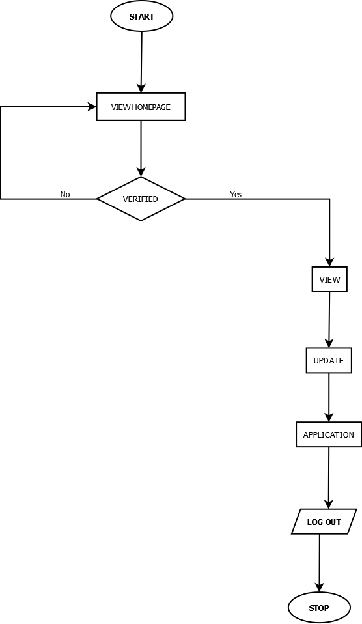**User part Flowchart :**
* **Admin part Flowchart :**

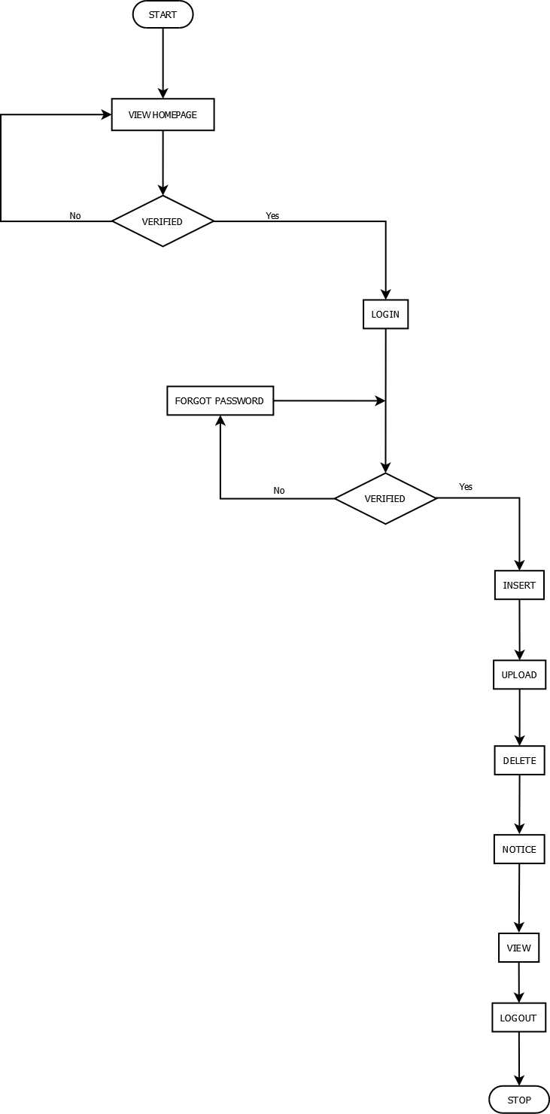

**Admin Module**

**Use Case Diagram**

Admin has the highest privileges among all as admin is responsible to design the system. Admin register employee and provide unique id to the employee. They are responsible to take images of the

employees and add them to the database. Admin can view and update the details of employees. They can also view the attendance report. Figure 1 shows the use case for admin,

**User Module**

User can verify in to the system. They can open the application and the images of the employees for attendance. They can also view the attendance report. Figure 2 shows the use case diagram.

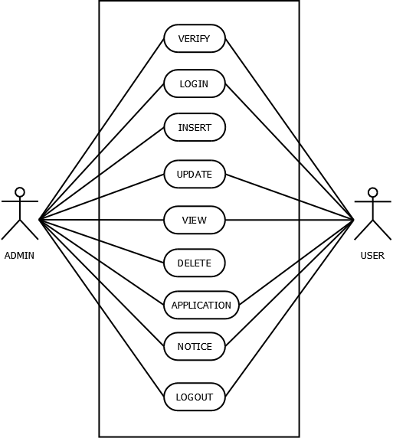

**Use Case Diagram**

#### Data flow diagram

* **Context level dfd:**

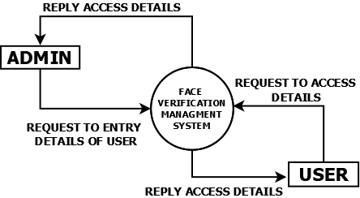

* **Level 1 (User):**

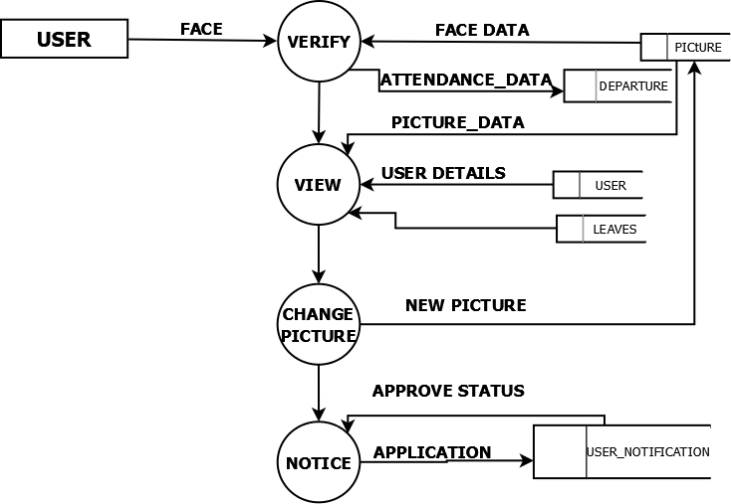

* **Level 1(Admin)**

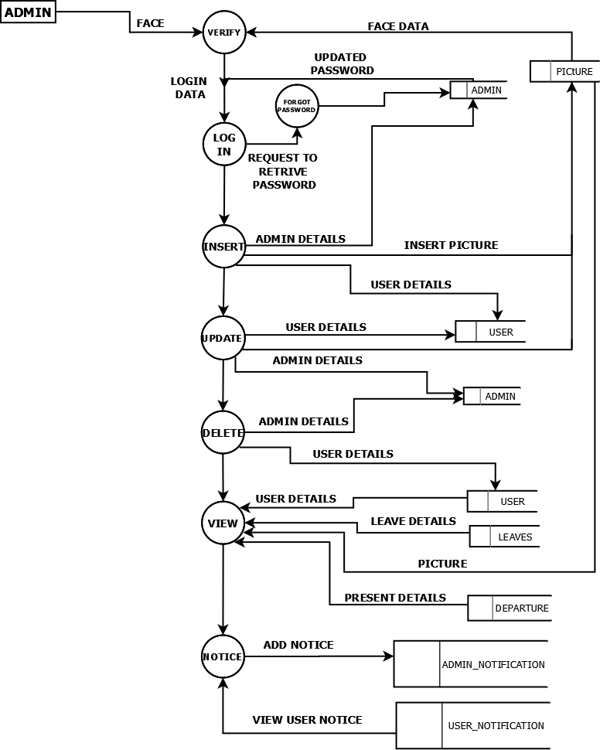

### ER diagram

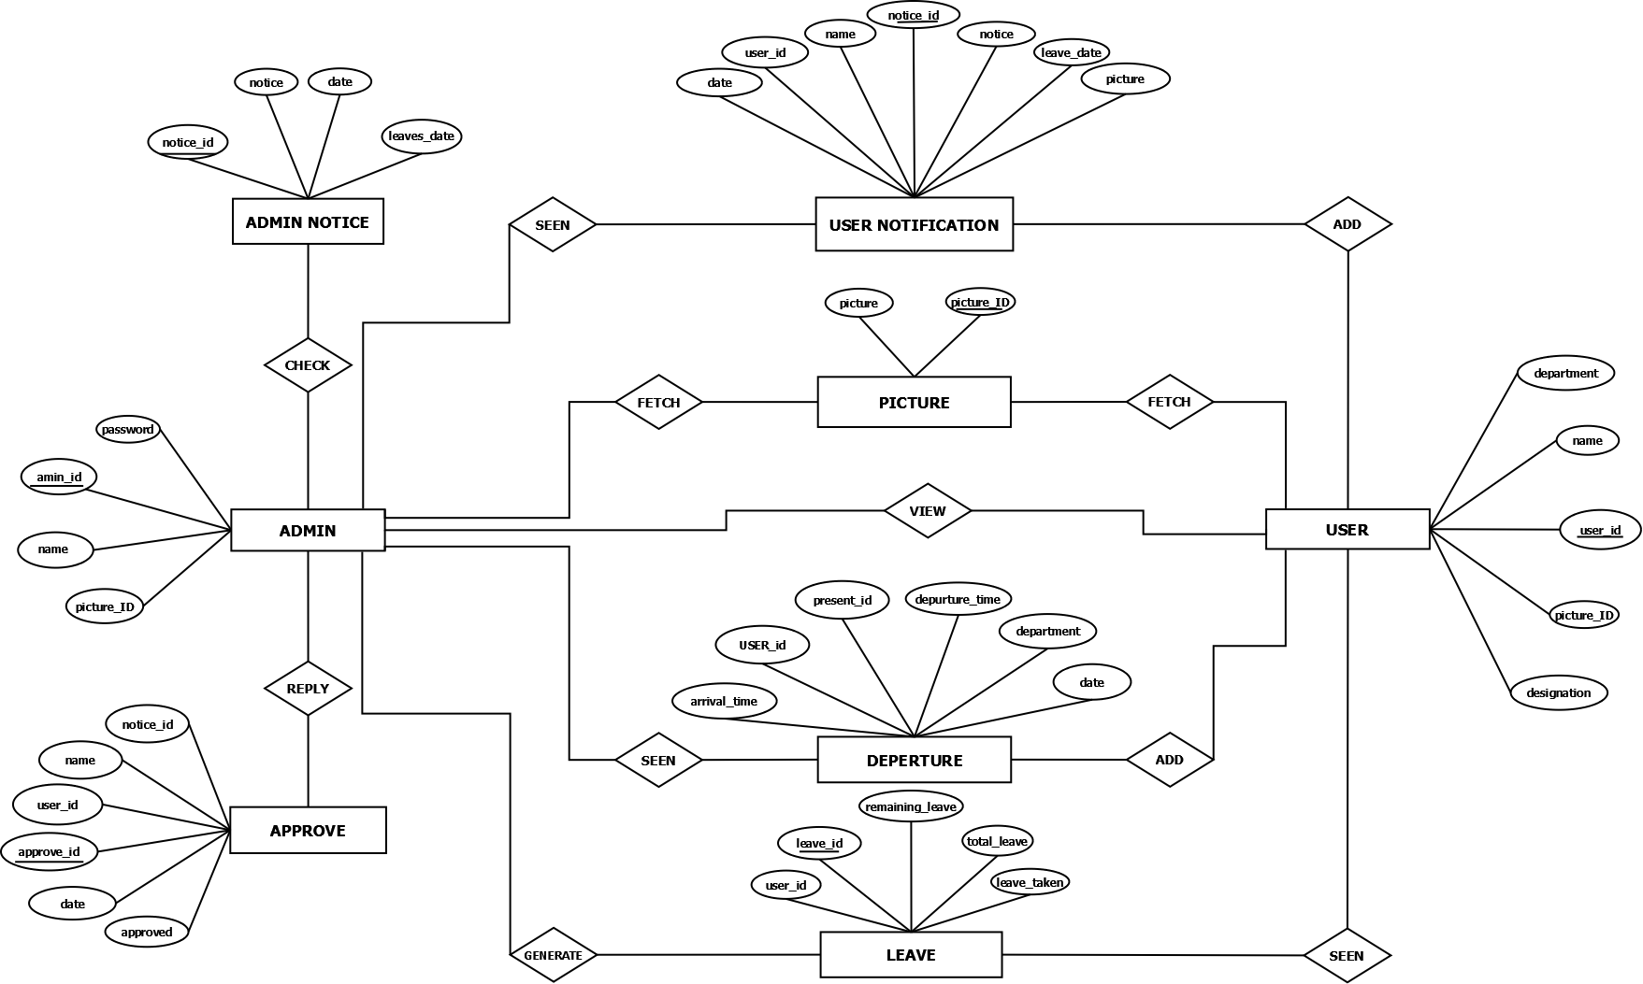

##### Code implementation

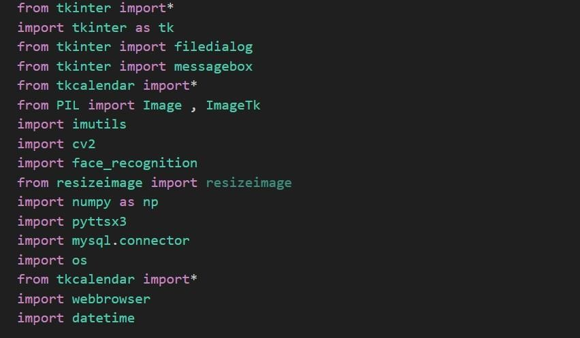

* **Import libraries :** Here we are import necessary library.



* **Mysql Connection :** Connection with mysql is shown above..

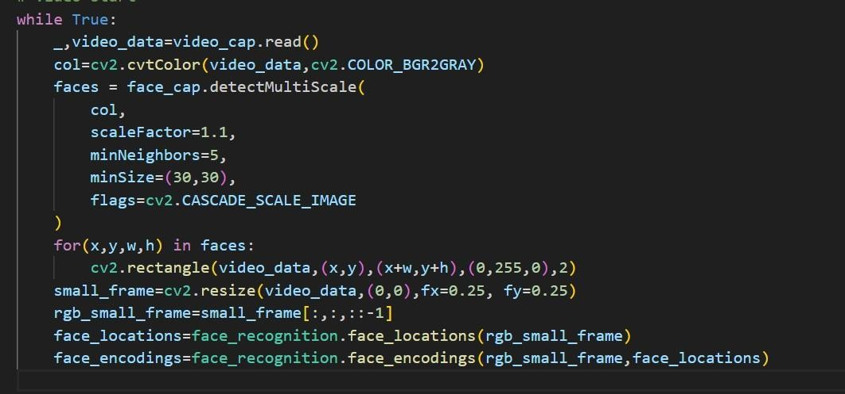

* + **Camera Start : In this part, we access the primary or secondary camera, for**

Verification purpose

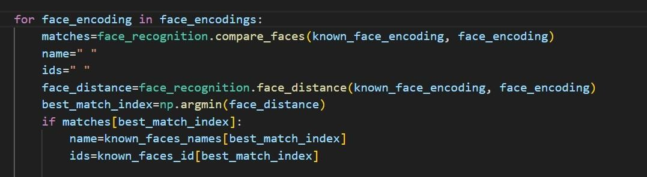

* + **Face match :** Matching The face between live camera and database image.

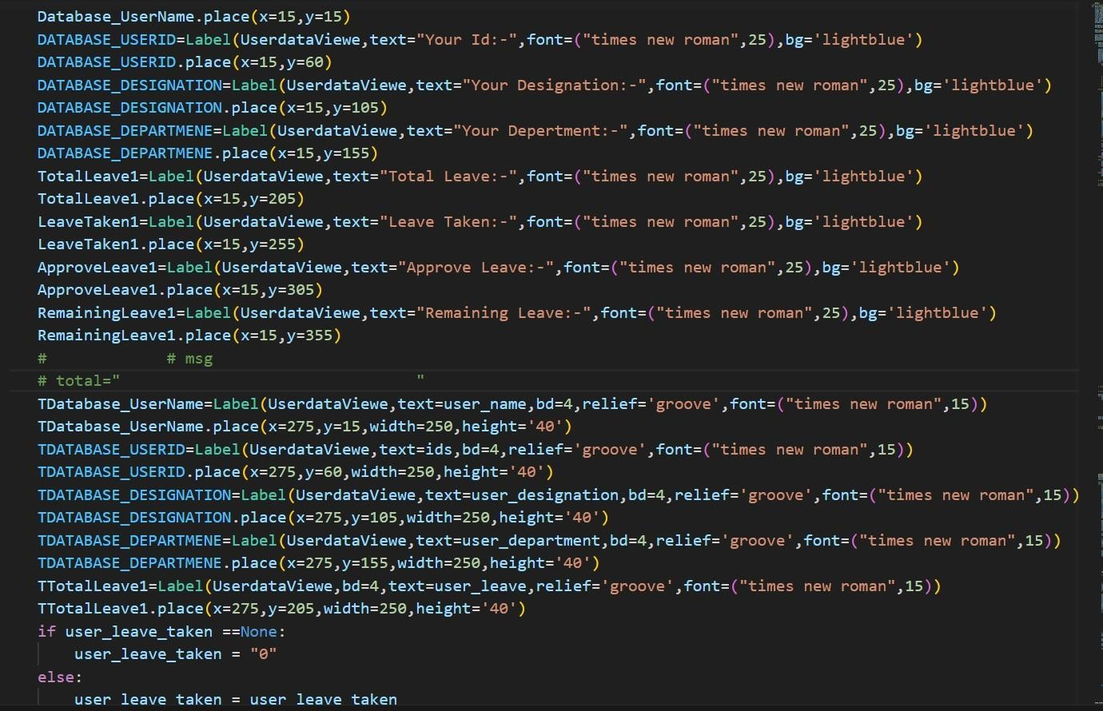

* + **Frontend :** In the total program many lines of code for frontend but few lines code are showing here. In this part an user can view his own profile.

##### User Interface

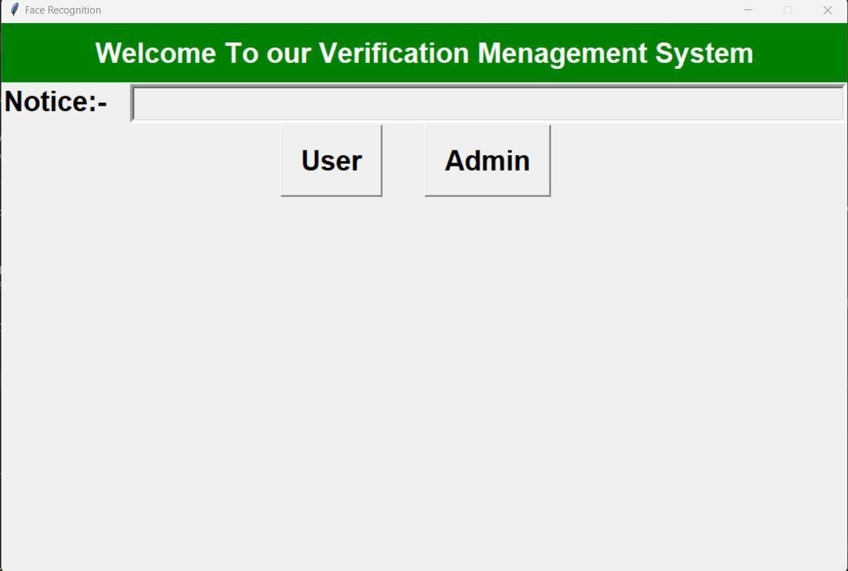

Fig:-Index page

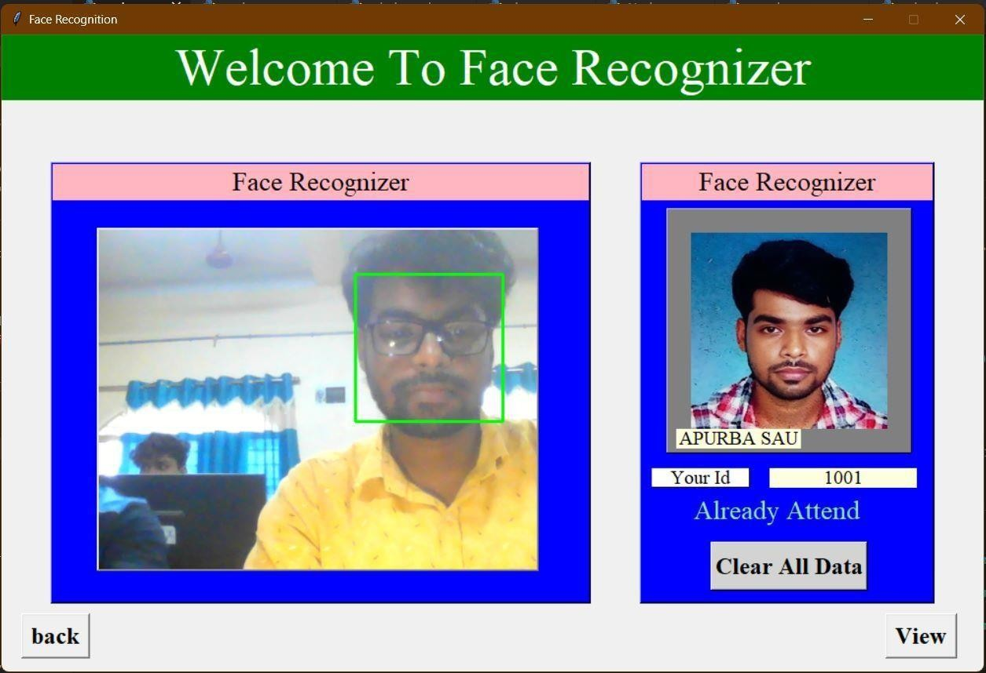

Fig:-User verification page

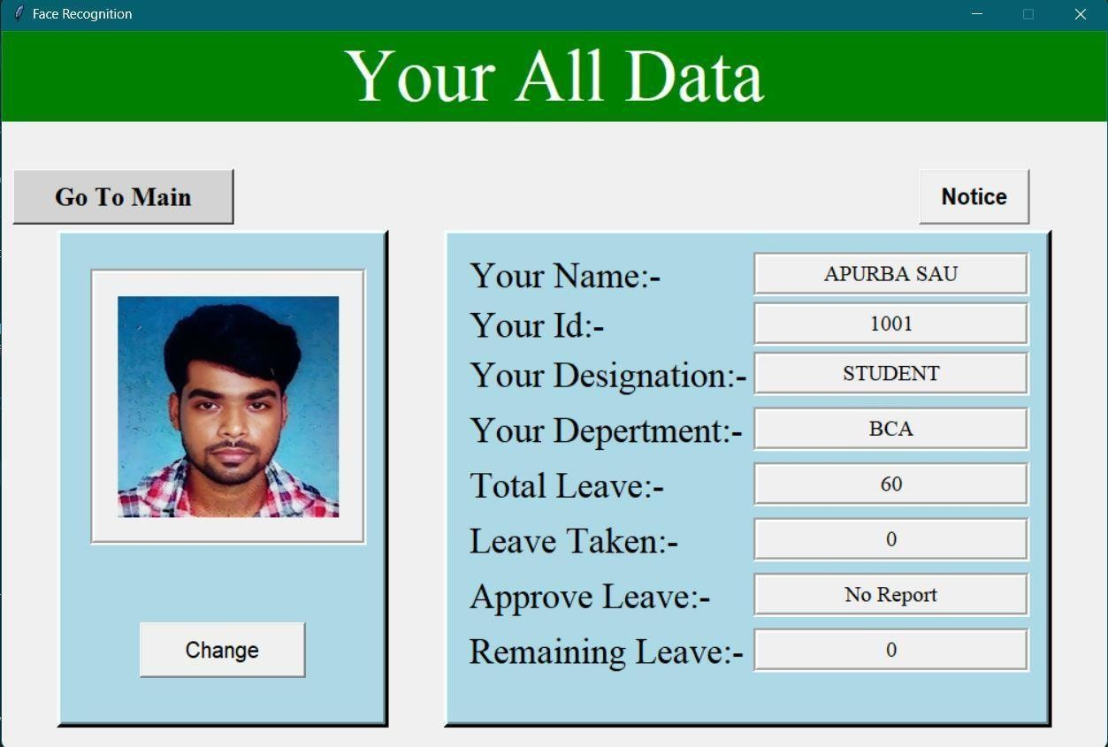

Fig:-Show user data page

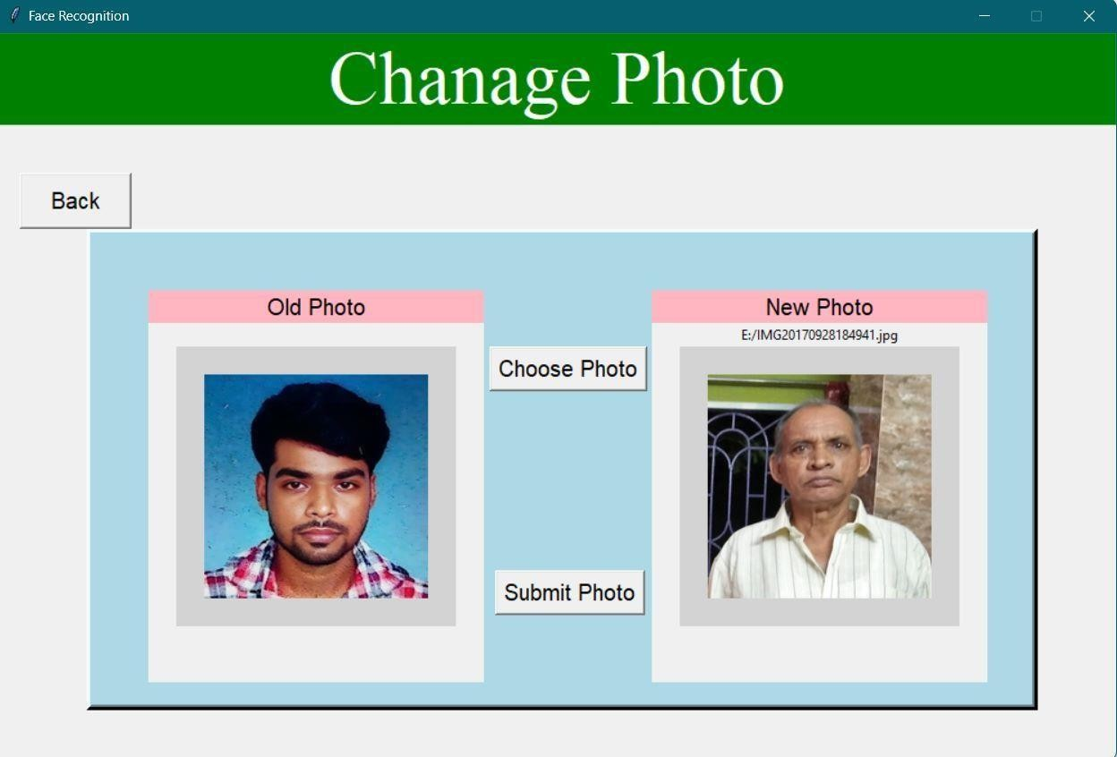

Fig:-Update user picture page

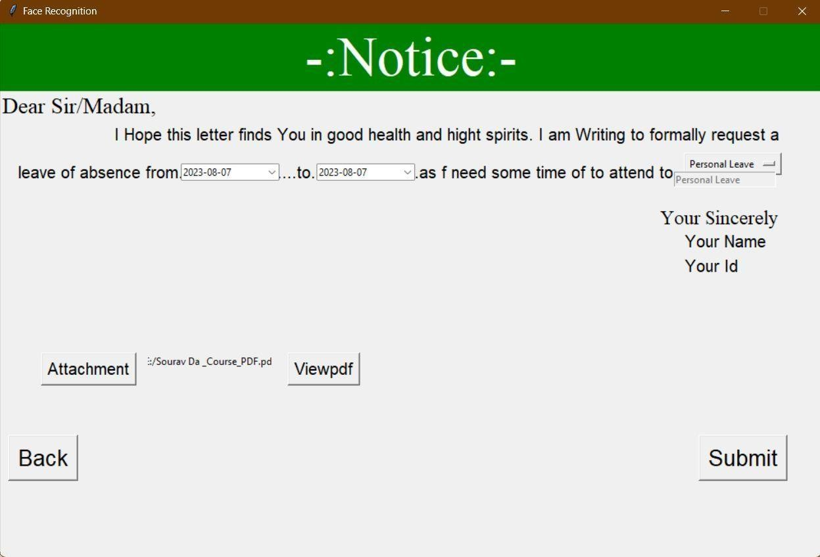

Fig:- User application page

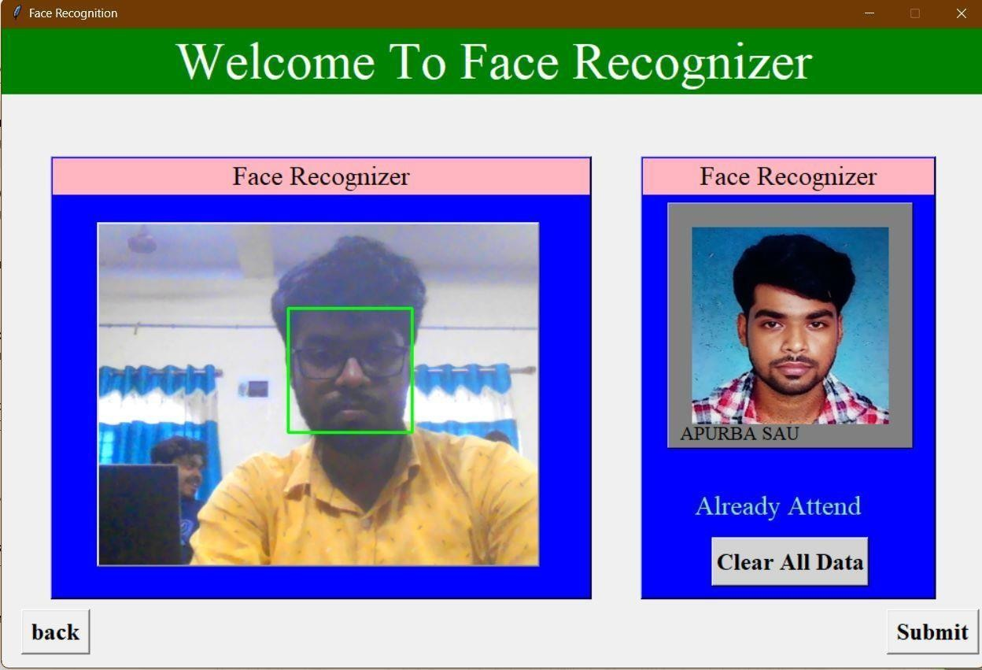

Fig:-Admin verification page

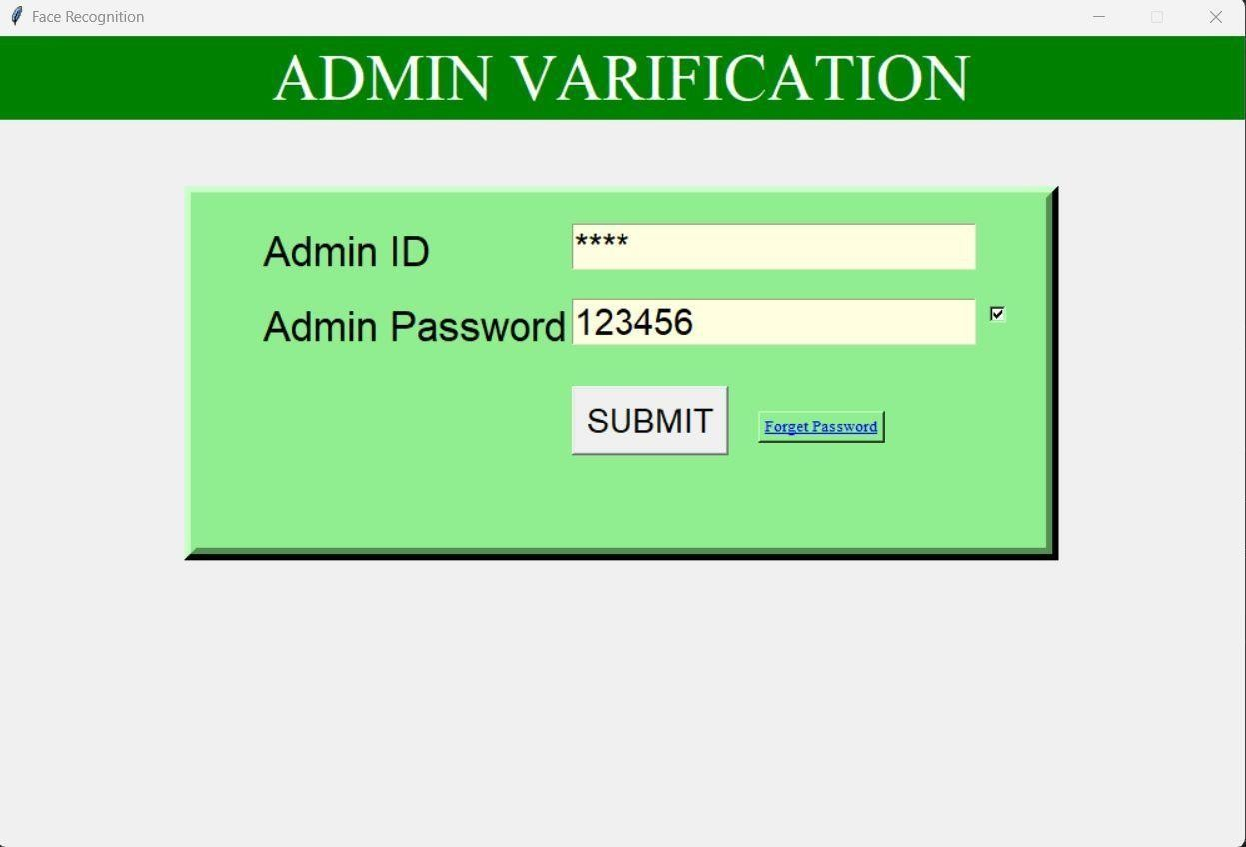

Fig:-Admin login page

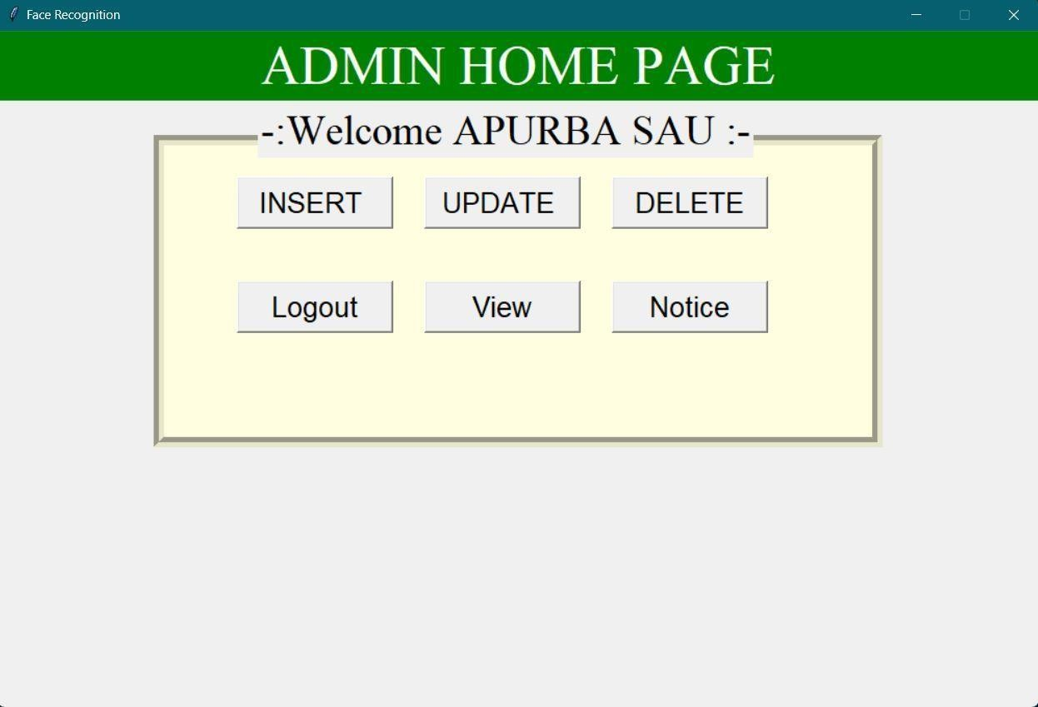

Fig:-Admin home page

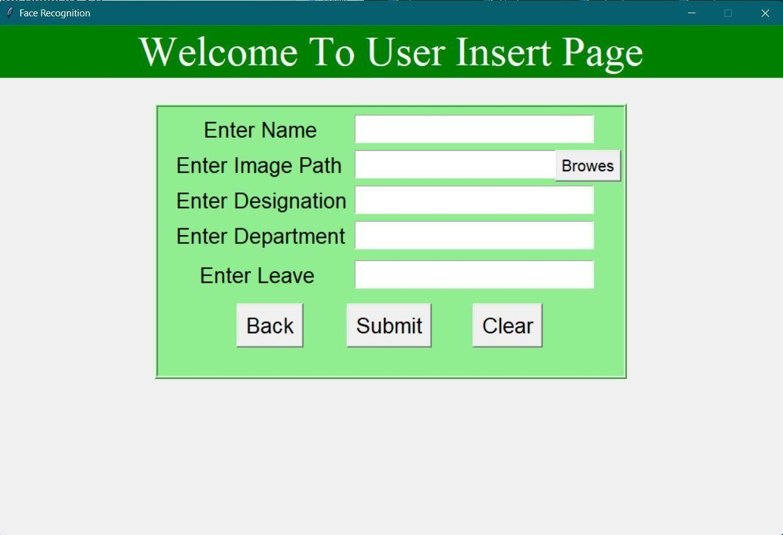

Fig:-User insert page

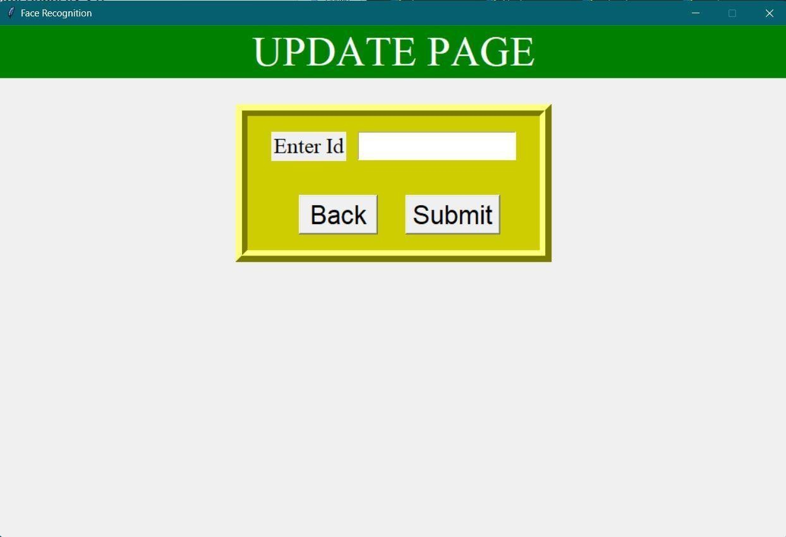

Fig:-Update user page

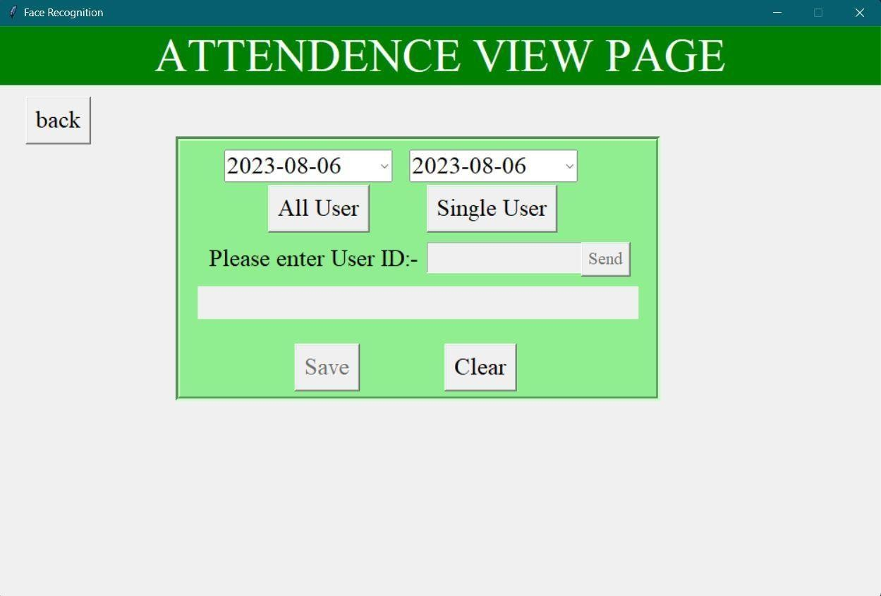

Fig:-Attendance view page

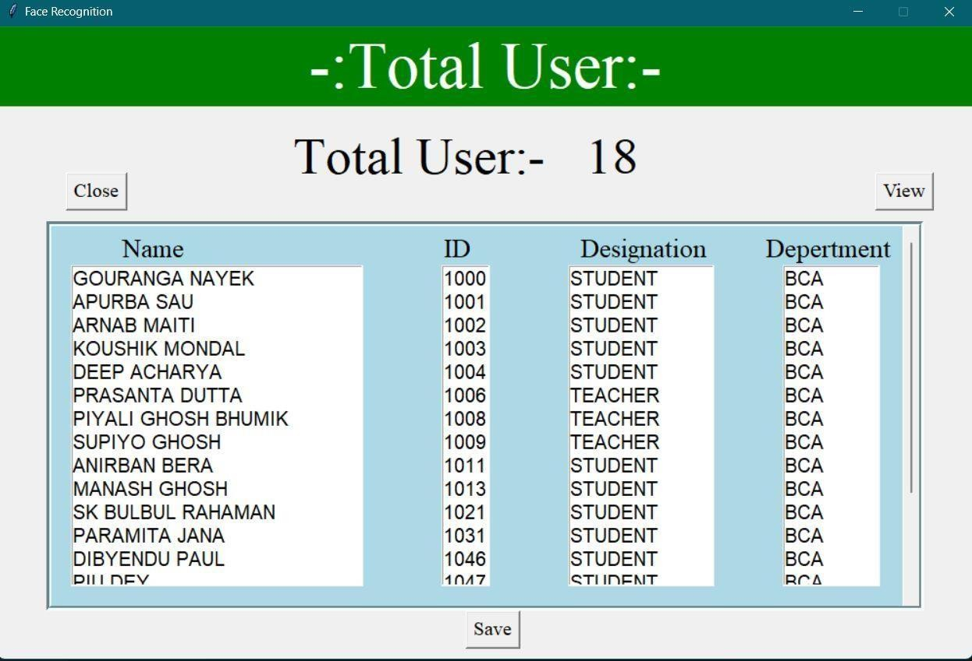

Fig:-Show all user data

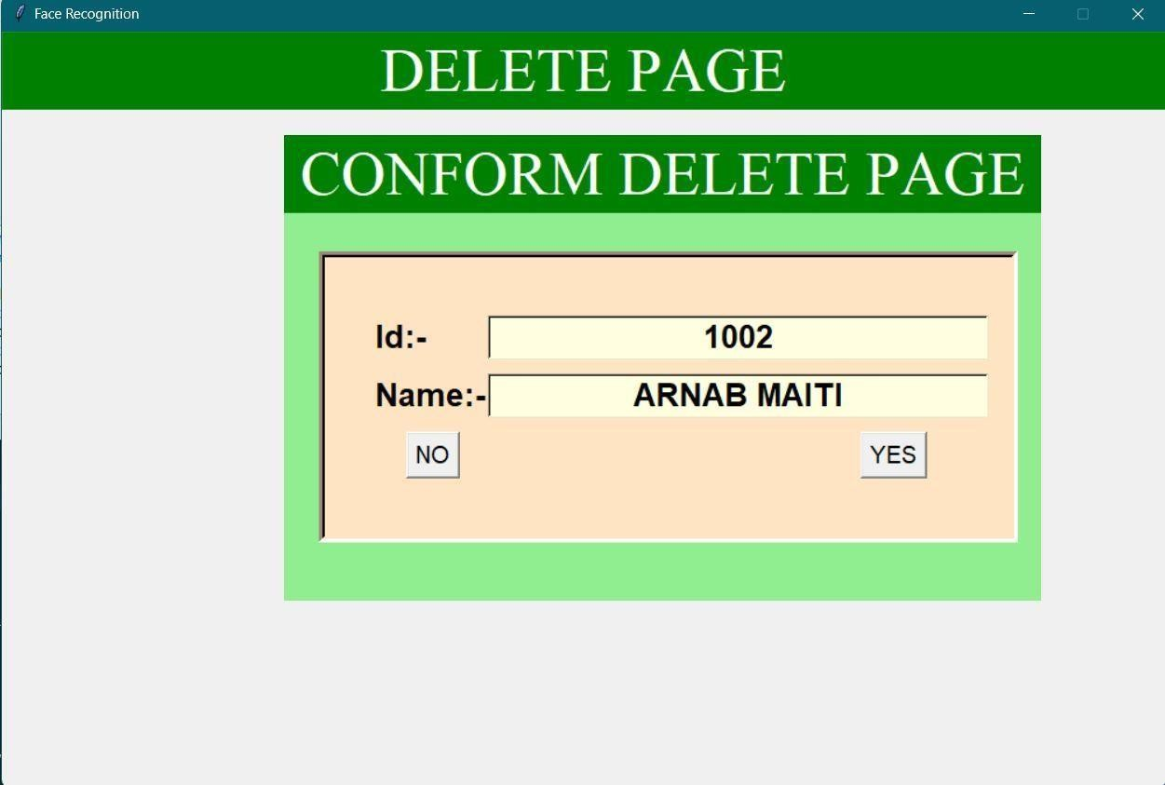

Fig:-Delete page

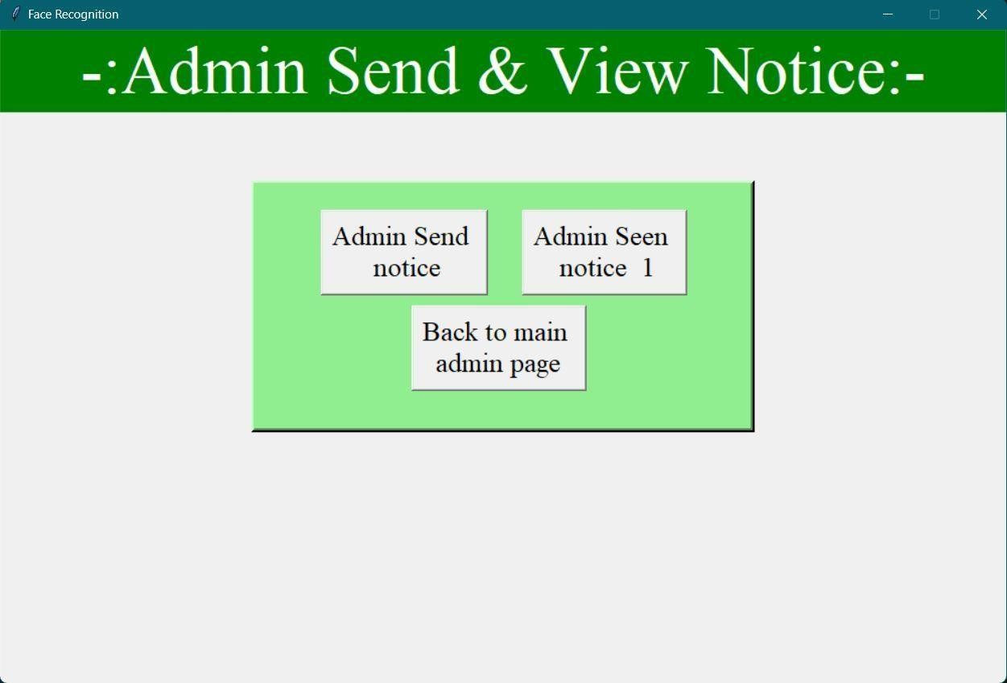

Fig:-Admin send and view notice page

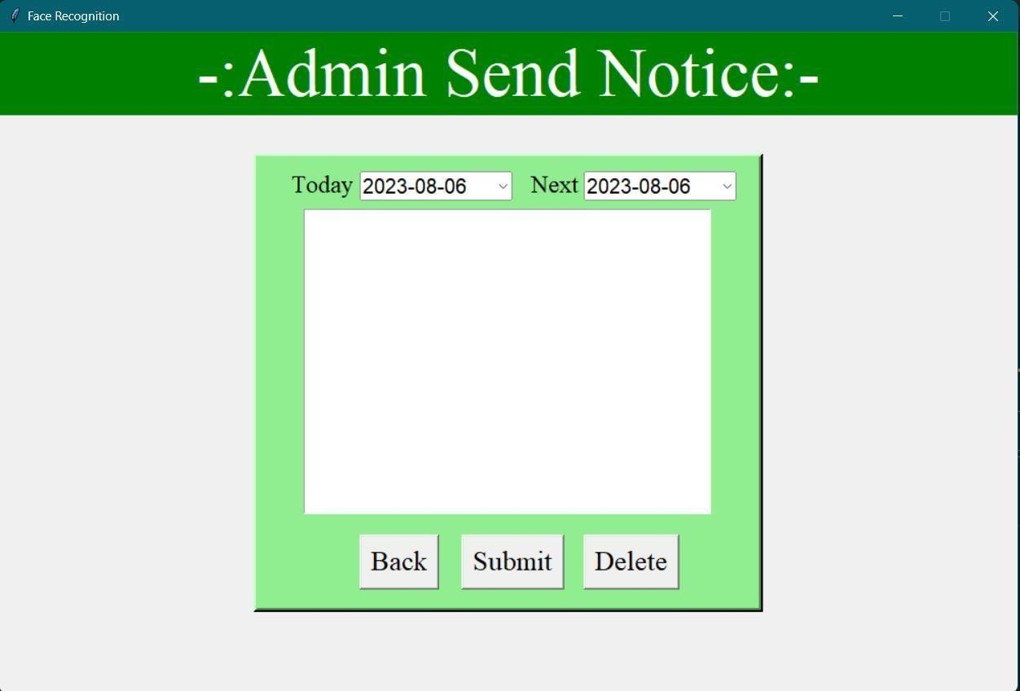

Fig:-Admin send notice

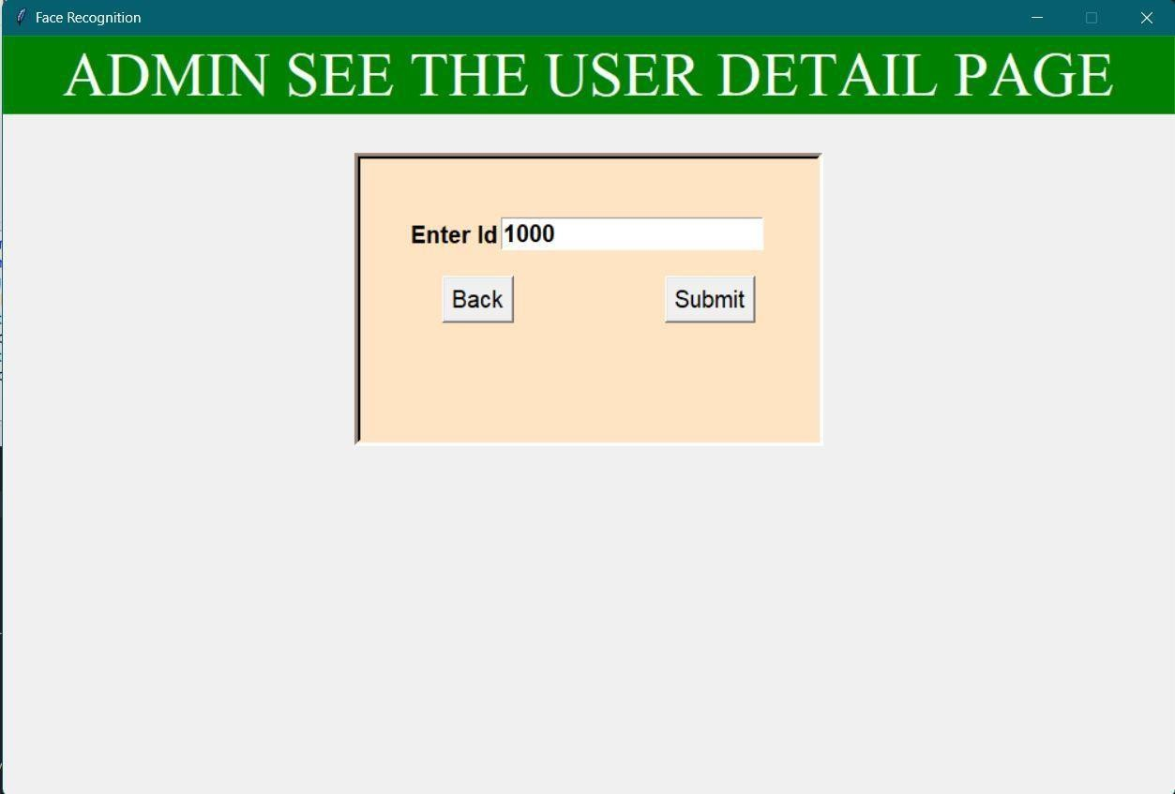

Fig:-Admin view user details page

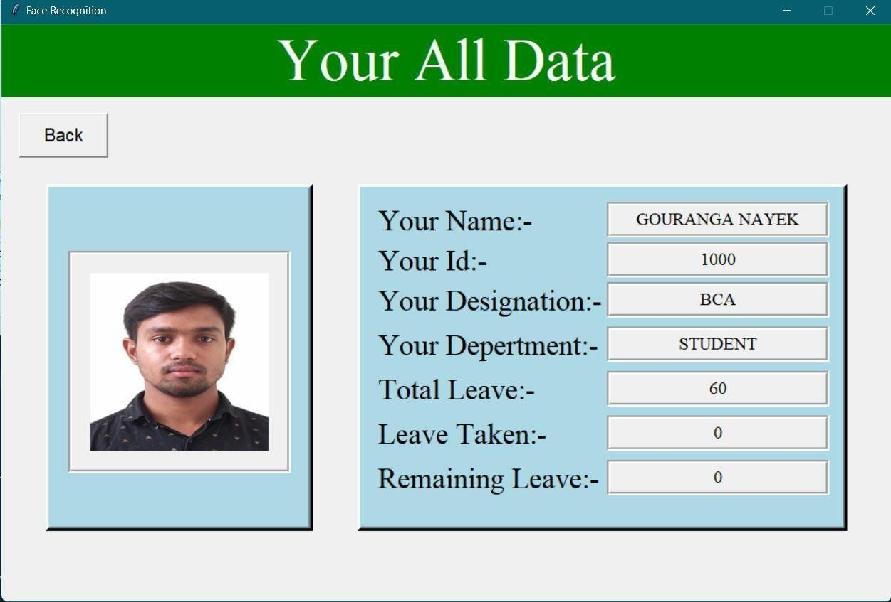

Fig:-Show user data page

**Advantage**

* User friendly
* Less paper work
* Fast access database and Les error
* More storage capacity

**Drawbacks**

* Required more light
* Required good camera quality
* It is not compatible with mobile device because mobile device developed in Android environment

**Future scope**

* Our next idea that we want to implement is this application database. We have used a local database, but we want to connect this database with a cloud database so that later we can detect faces from any camera from any place. Nowadays, CCTV cameras, or hidden

cameras, are used in all the roads and organisations, big and small, so we can identify

some suspicious persons from all the information obtained from these cameras by our project

* We want to use our project in a positive way, like helping the crime investigation department. Nowadays, CCTV cameras are used everywhere. In this project, we will try to detect any criminals with that CCTV camera footage. For example, someone did a bad deed by putting a fake beard on his face, and the police put a real photo of that suspect in this application. Our project is to use the face of the person seen on that camera. Whether the picture of this suspicious person is similar or not Through this project, the punishment for

the innocent person will be less, and the guilty person will be caught very easily. This is

how we want to implement this project

**Result and Discussion**

As this was a small-scale project, data structure and implementation did not have many problems. However, it took the author many effort with research and study with different technologies neededas these tools and technologies were new to the author. This caused a delay in the development of the project.

Despite the delay and difficulties, the author was able to incorporate those tools and technologiesand complete the project. However, the success rate of facial recognition was not as expected. Thesuccess rate depended upon the quality of the camera, lighting, and sufficient dataset in the database. When these factors were to be managed properly, the success rate of face recognition

increased.

The effort that went to learn and research about LBPH and MySql and other tools and technologies was worth it. While the process of researching and implementing was overwhelming, it started to be interesting as the project started to show some results. This project gave the author first-hand experience in working on a project using MySql and found MySql easier and more scalable.

#### Conclusion

The goal of the project was to build a facial recognition system for employee’s attendance. Conceptsof facial recognition and LBPH is heavily discussed in this thesis. Similarly, web development with MySql is also discussed, followed by examples of implementation and explanations.

The result of the project was a successful prototype of a facial recognition system where the admincan create a employee account and add employees and their information to the database. Admin

then can log in to the system and take attendance of the employee. The employee’s face is detectedby a camera and attendance is recorded in the database.Aadmin could see the

attendance report of the employees.

Overall, the project was successful in its showcasing how LBPH can be implemented in MySql to create a web application. Once implemented, it can be used to take attendance of employees and keep track of their attendance records. This project has the potential for further development in thefuture by adding more features for employees and teachers. More features such as assignments,

results, and grades could be added.

#### References

* [**https://www.google.com/**](https://www.google.com/)
* [**https://pypi.org/**](https://pypi.org/)
* [**https://www.mysql.com/**](https://www.mysql.com/)
* [***https://www.geeksforgeeks.org/***](https://www.geeksforgeeks.org/)
* [***https://www.youtube.com/***](https://www.youtube.com/)
* [**https://www.w3schools.com/**](https://www.w3schools.com/)